Задание 1

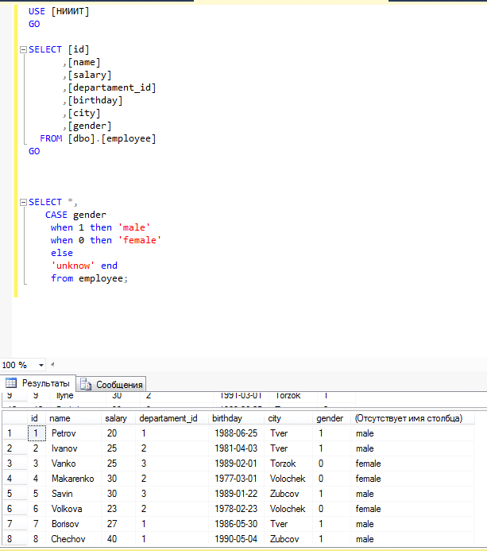

SELECT *,

CASE gender

when 1 then 'male'

when 0 then 'female'

else

'unknow' end

from employee;

1.1

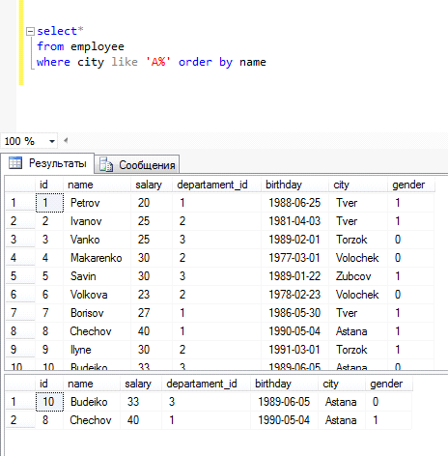

select*

from employee

where city like 'A%' order by name

1.2

select * from employee

where DATEADD (year, DatePart(year, getdate()) - DatePart(year, birthday), birthday)

between convert(date, getdate(), 0)

and convert(date, DateAdd(day, 0, getdate()), 0)

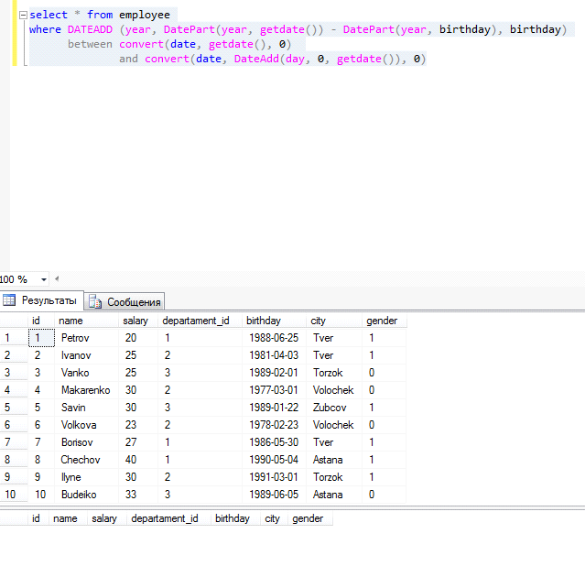

1.3

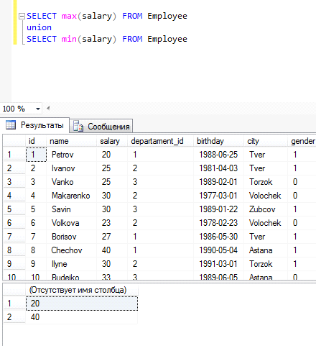

SELECT max(salary) FROM Employee

union

SELECT min(salary) FROM Employee

1.4

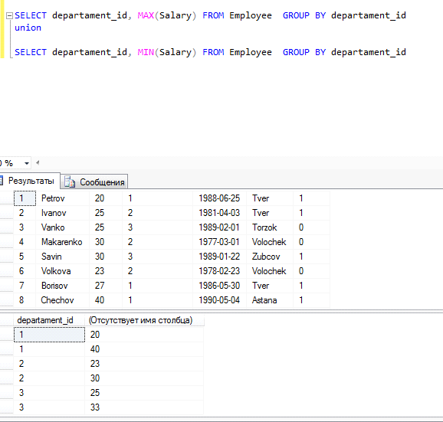

SELECT departament_id, MAX(Salary) FROM Employee GROUP BY departament_id

union

SELECT departament_id, MIN(Salary) FROM Employee GROUP BY departament_id